Sprint Planning:

Cubic File Management System V1.0

1. Project needs to be completed in 2 sprints: Approx. 10 working days
2. Developer for the initial release: Jayanta Acharjee
3. We are using Git Project Dashboard for tracking. Required Work Items are created in Git Projects To Do List.
4. New Features to be marked as NF, Bugs are BG, Product Backlog as PB and change request are CR.
5. Initially all Work Items are mapped under to do list.
6. Work Items List:
7. NF001: Main Menu and Sub Menu options to be configured.
8. NF002: Java File Management System Console App Welcome Page
9. NF003: Logic for Adding a file
10. NF004: Logic to View list of files available
11. NF005: Logic for Deleting a file
12. NF006: Logic for Searching a file
13. NF007: Print Proper Error Messages
14. NF008: Logic for Exiting from Console App
15. Sprint 1: First 4 WI work Items: NF001 to NF004 needs to be completed.
16. Sprint 2: Last 4 WI Work Items: NF005 to NF008 needs to be completed.
17. To do list screenshot 1

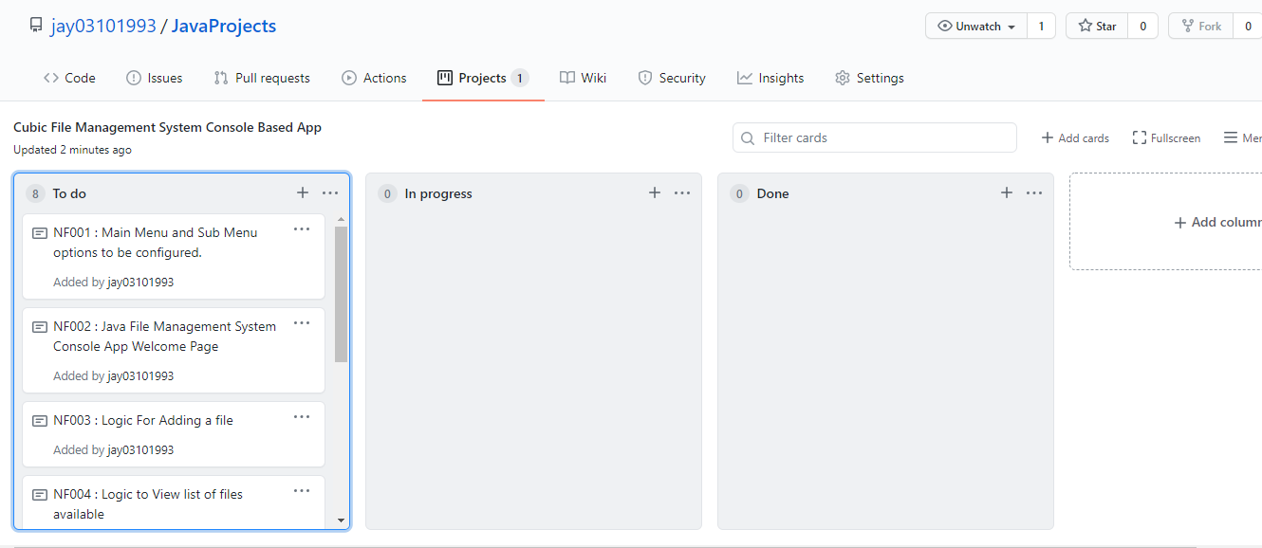

1. To do list screenshot 2

